Title: Stock Sentiment Analyzer using Macgine Learning
Done by : Pritesh Ram Keshri Project Number : 17, Submission Date: 21st July 2025
Overview:

This project aims to assist traders and investors by analyzing the public sentiment of stock market tickers using recent news headlines. The tool scrapes headlines via NewsAPI and classifies them using a transformer-based sentiment analysis model (twitter-roberta-base-sentiment). Based on the analysis, it predicts market mood as Bullish, Bearish, or Neutral.
Libraries used:

- transformers, torch – Sentiment model loading and prediction
- requests – API communication
- streamlit – Interactive web UI
- snscrape – Optional Twitter scraping module
- numpy, pandas – Data structuring

Dataset Details:

- News Headlines Source: NewsAPI.org
- Model: cardiffnlp/twitter-roberta-base-sentiment (Pretrained on Twitter)
- Stock Input: Any valid stock ticker or company name
- Output:
- Sentiment distribution (% Positive, % Neutral, % Negative)
- Market sentiment classification: Bullish, Bearish, or Neutral

APIs Integrated:

No external APIs were used.

Source code 1: File Name : app.py — Main Streamlit Web App
import streamlit as st
from news_scraper import get_news_headlines
from sentiment_model import analyze_sentiment
from utils import predict_market_impact
from transformers import AutoTokenizer, AutoModelForSequenceClassification

st.set_page_config(page_title="📊 Stock Sentiment Analyzer", layout="centered")

@st.cache_resource
def load_model():
tokenizer = AutoTokenizer.from_pretrained("cardiffnlp/twitter-roberta-base-sentiment")
model = AutoModelForSequenceClassification.from_pretrained("cardiffnlp/twitter-roberta-base-sentiment")
return tokenizer, model

tokenizer, model = load_model()

st.title("📊 Stock Sentiment Analyzer")
st.write("Analyze news sentiment for your favorite stock and predict market mood.")

stock_input = st.text_input("Enter stock/company name (e.g., TCS, INFY, Tata Consultancy Services)")

keyword_map = {
"TCS": "Tata Consultancy Services",
"INFY": "Infosys",
"RELIANCE": "Reliance Industries"
}

api_key = "" # Replace with your NewsAPI key

if stock_input:
query = keyword_map.get(stock_input.upper(), stock_input)
st.info(f"🔍 Fetching news for: **{query}**")

headlines = get_news_headlines(query, api_key)

if not headlines:
st.error("❌ No relevant news found.")
else:
st.subheader("📰 Top Headlines")
for i, headline in enumerate(headlines, 1):
st.markdown(f"{i}. {headline}")

st.subheader("🧠 Sentiment Analysis")
sentiment_scores = analyze_sentiment(headlines, tokenizer, model)

st.write("### 📊 Sentiment Breakdown")
st.bar_chart(sentiment_scores)

impact = predict_market_impact(sentiment_scores)
st.success(f"🔮 **Market Prediction**: {impact}")

Source code 2: news_scraper.py — NewsAPI Integration
import requests

def get_news_headlines(stock_name, api_key):
url = f"https://newsapi.org/v2/everything?q={stock_name}&apiKey={api_key}"
res = requests.get(url).json()
return [article['title'] for article in res['articles'][:10]]

Source code 3: sentiment_model.py — Sentiment Model Loader & Analyzer
from transformers import AutoTokenizer, AutoModelForSequenceClassification
import torch

def load_model():
model_name = "cardiffnlp/twitter-roberta-base-sentiment"
tokenizer = AutoTokenizer.from_pretrained(model_name)
model = AutoModelForSequenceClassification.from_pretrained(model_name)
return tokenizer, model

def analyze_sentiment(texts, tokenizer, model):
labels = ['negative', 'neutral', 'positive']
results = {l: 0 for l in labels}

for text in texts:
inputs = tokenizer(text, return_tensors="pt", truncation=True)
with torch.no_grad():
outputs = model(**inputs)
scores = torch.nn.functional.softmax(outputs.logits, dim=1)
pred = labels[torch.argmax(scores)]
results[pred] += 1

total = sum(results.values())
return {k: round((v / total) * 100, 2) for k, v in results.items()}
Source Code 5: utils.py — Market Impact Prediction
def predict_market_impact(sentiment_scores):
if sentiment_scores["positive"] > sentiment_scores["negative"]:
return "Bullish"
elif sentiment_scores["negative"] > sentiment_scores["positive"]:
return "Bearish"
else:
return "Neutral"
Output screenshots:

1. Initial App Interface- This is the landing interface of the Stock Sentiment Analyzer.
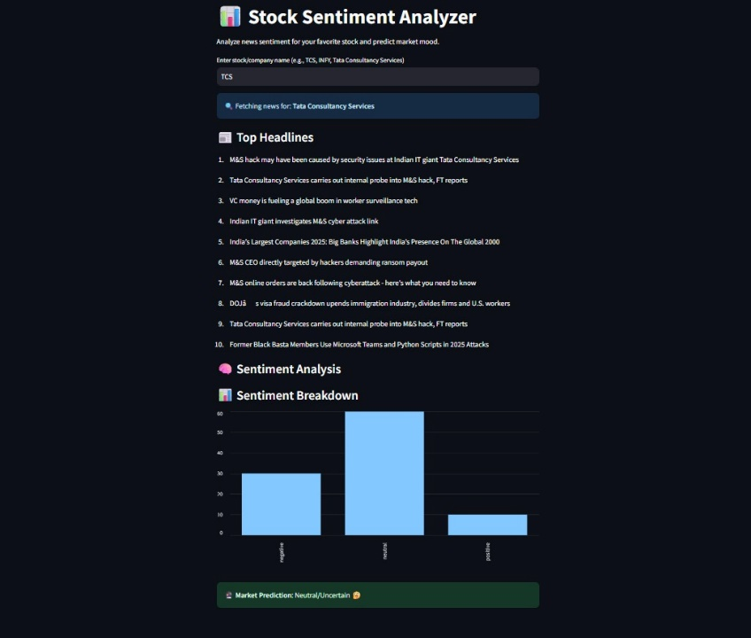

2. Sentiment Output for Stock Query (TCS): Coffee: Once a stock name is entered (e.g., TCS), the app displays.
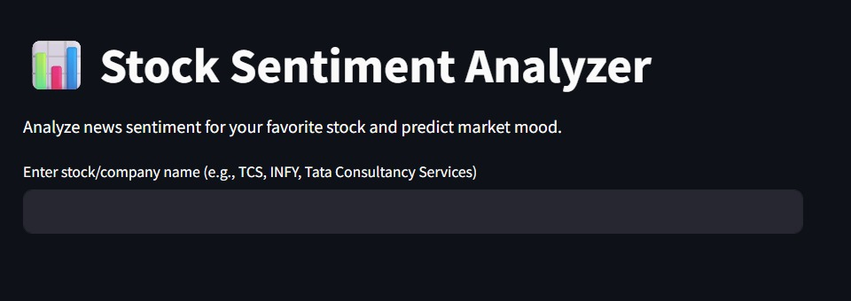

What you learned:
Through this project, I gained practical knowledge of:
- Practical integration of NLP transformer models (HuggingFace)
- Web-based sentiment dashboard building using Streamlit
- API integration and caching
- Real-time data processing

What the Skills you gained:

- Transformer-based Sentiment Analysis
- Streamlit UI Development
- News API Integration
- Sentiment Aggregation & Visualization
- API Rate Handling and Error Handling

Real Time Applications:

- Investor Sentiment Analysis: Gauge public mood for specific stocks based on news headlines.
- Trading Signal Generator: Trigger automated bullish/bearish/neutral signals based on aggregated sentiment.
- News Sentiment Monitoring Tool: Track how sentiment evolves over time for companies in the stock market.
- Social + News Sentiment Fusion: Combine Twitter and news headline sentiments for a broader perspective.
- Portfolio Risk Estimation: Predict sentiment-based volatility for individual or grouped stocks.
- Real-Time Stock Dashboard: Provide investors with a live dashboard summarizing market emotion.

Further Enhancement Suggestions :

- Twitter Sentiment Integration: Combine live tweets with news headlines for richer sentiment data.
- Sentiment Trend Visualization: Visualize sentiment movement over past days or weeks.
- Stock Price Correlation: Integrate financial APIs (e.g., Alpha Vantage, Yahoo Finance) to correlate sentiment with stock prices.
- Multilingual Support: Use translation APIs to analyze non-English news content.
- Mobile App Deployment: Convert the app to a mobile interface for traders on-the-go.

